**Lab report 08**



**CSE 402L**

**Digital Signal Processing Fall 2024**

**Submitted by: Naveed Ahmad**

**Registration No.: 22PWCSE2165**

**Class Section: B**

**Semester :5th**

Student Signature: ____________

Submitted to:

**Dr. Yasir Saleem Afridi**

Dec. 24, 2024

Department of Computer Systems Engineering

University of Engineering and Technology Peshawar

**SIMULINK TRAINING TO DEMONSTRATE THE USE OF SIMULINK PRODUCTS**

Task:

Visit the following website: <https://www.mathworks.com/learn/tutorials/simulink-onramp.html> and perform the following tasks and attach the Certificate/ Progress Report acquired from MathWorks as part of the lab Report

**OBJECTIVES:**

1. Course Overview
   * + to learn about the Simulink Onramp course.
     + to understand the basics of Simulink software.
     + and get ready to start hands-on practice.
2. Simulink Graphic Environment
   * + - **Simulink Blocks**: Blocks represent different parts of a system (e.g., mathematical operations, integrators, sources of signals). For example:
       - **Source blocks**: Generate input signals (e.g., step, sine wave).
       - **Math blocks**: Perform operations like addition, multiplication, etc.
       - **Scope blocks**: Display results of simulations.
       - **Signals**: Signals carry information between blocks. They can represent data like time, position, velocity, or force, and are connected between blocks using lines in the Simulink environment.
3. Inspecting Signals

* **Signals** carry information between blocks in your model.
* **Visualizing signals** means seeing how the values change over time.
* Use the **Scope block** to show graphs of these values during the simulation.

Screenshot

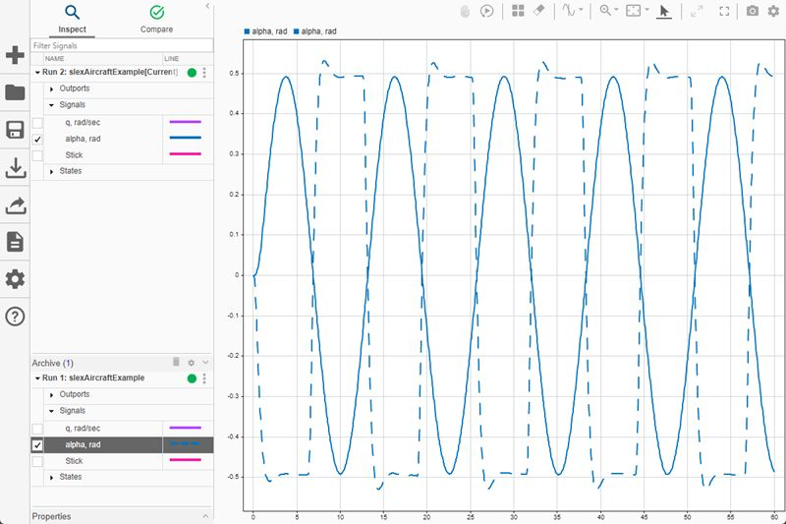

Develop simple algorithms and solve basic problems in Simulink by mastering the use of math and logic blocks.

Screenshot:

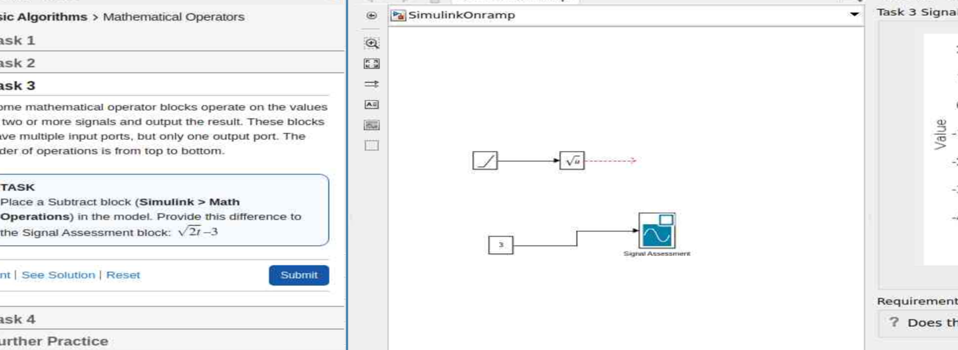

Learnt to open Simulink help. Use documentation and understood blocks. Found answers to our questions easily.

Screenshot:

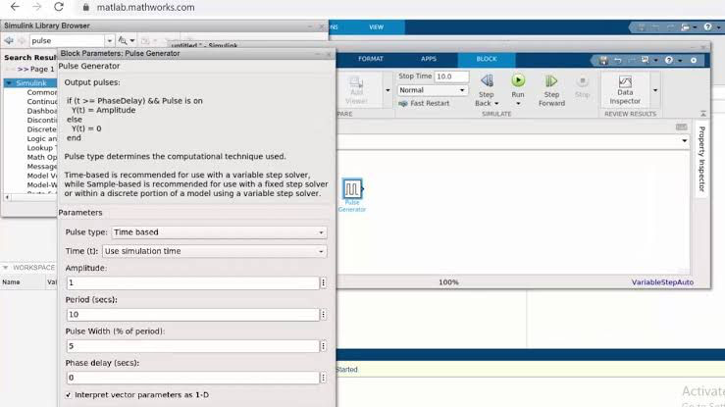

Simulink and MATLAB offer math and logic operators for calculations and decision-making. Simulink models dynamic systems with changing states over time. It also supports discrete-time systems, enabling step-by-step simulations.

Screenshot:

**1. Continuous-time systems** - These systems change continuously, like car motion or electricity flow.

**2. Modeling** - Simulink uses blocks (e.g., integrators, transfer functions) to model and simulate system behavior.

**3. Block Connections** - Connecting blocks creates continuous models to simulate system behavior over time.

**4. Simulation Time** - Set how long the simulation runs (e.g., 10 seconds, 1 minute).

**5. Control Settings** - Simulation duration defines how long the system’s behavior is modeled.

Screenshot:

**Project - Modeling a Thermostat**  
Simulate a discrete system where the thermostat checks temperature at intervals and switches on/off based on conditions.

**Project - Peregrine Falcon Dive**  
Model forces acting on a falcon during a dive using blocks for gravity, drag, and net force. Simulate velocity and position changes over time.

***Conclusion:*** *The Simulink Onramp course teaches modeling and simulating dynamic systems using blocks and signals. It helps visualize real-world behavior and develop essential simulation skills.*

Progress report:

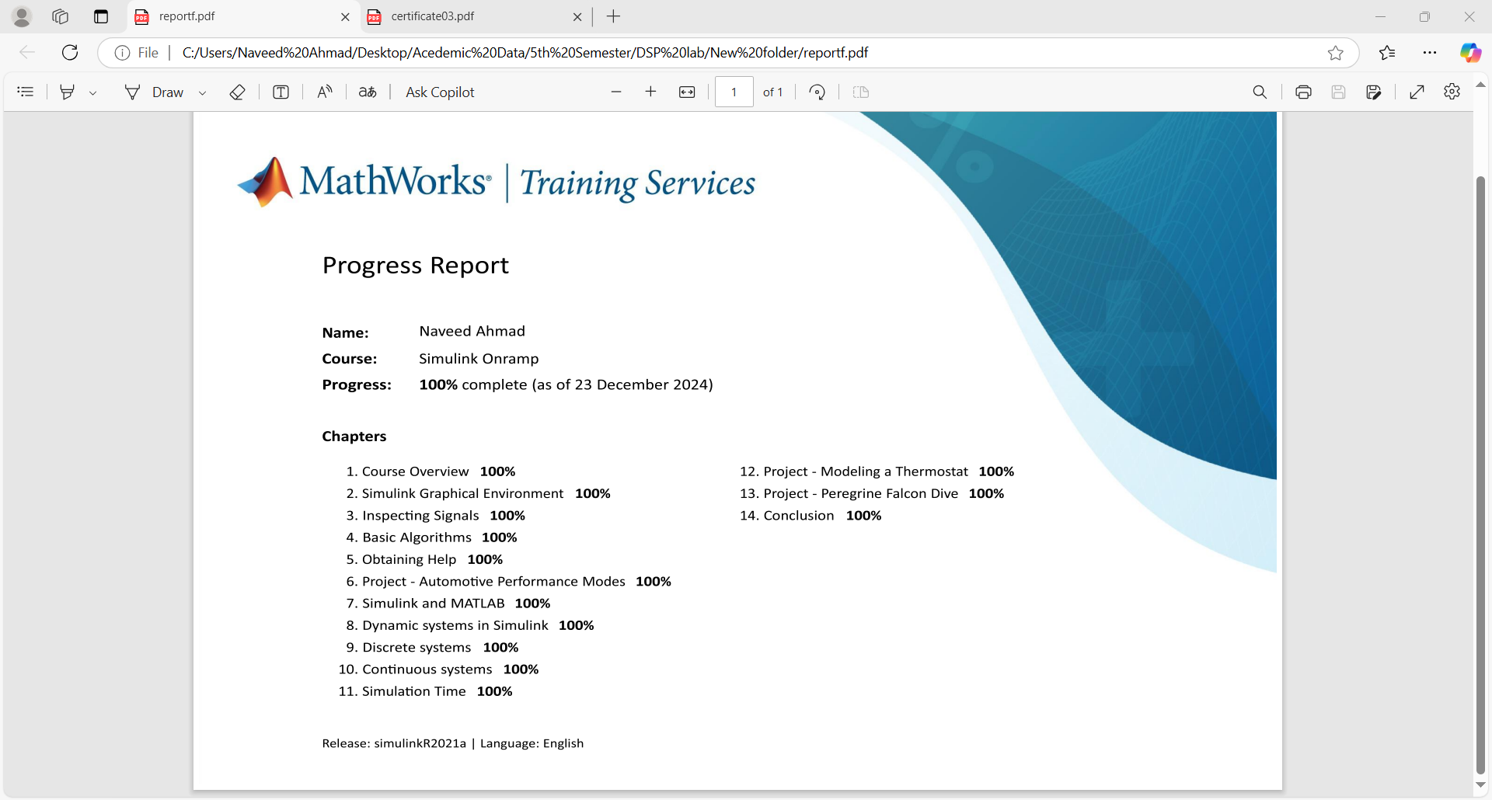

Certificate:



